DIGITAL CONTENT GUIDELINES
EU INTERNATIONAL PARTNERSHIPS

CONTENT TYPE: STORIES

Why we use stories
Storytelling builds connections among people, and between people and ideas. Stories convey the culture, history, and values that unite people. The best way to connect with people is by telling real stories. These stories show how the EU is creating opportunities and improving lives, in a way that people identify with, remember and act upon.

When identifying stories to share, consider which stories demonstrate the most significant changes to individuals or communities. This approach can help determine key questions to identify what the change is, how it came about, and when it occurred.

Information should not focus on the traditional donor-recipient relationship, or prioritise input over output. Instead, it should focus on the values underlying the action, the approach taken, and the impact achieved.

Sharing information does not mean bombarding our audiences with technical jargon or overly complex policy explanations. On the contrary, using clear and simple language is appreciated by experts and layman alike and will have more positive impact on people, as they are more likely to remember and act on the information communicated.

Photos and videos also play an important part of the story.

See our digital content guidelines for more guidance on tone of voice, photos and videos.

How to use this template
This template is designed to help you provide the type of content we publish on the EU International Partnerships website. It is pre-filled with an example: Woman engineer paves the way for groundwater access in Zambia
Simply replace the text and photos in the pre-filled sections and send the template back to INTPA-WEB@ec.europa.eu
Fields marked with a * are obligatory.
Please note that the text may be edited to comply with European Commission guidelines for content on ‘Europa’.
Please provide the name and email address of someone we can contact if we have further questions on this story:
Contact person name and email address

Title *  Use short, engaging titles: Who? What? Where? | Woman engineer paves the way for groundwater access in Zambia
Story preview picture *  This picture is used on the index page for stories. It can be used on the story page itself too.  Use a meaningful picture that underlines the story. Don’t forget to indicate the copyright holder and ensure you have the permission of any subjects in the photo. | © World Bank
Image caption  Necessary if the image will be used on the ‘story page’ itself. | Beatrice Kanyamuna-Pole, senior hydrogeologist at the Department of Water Resource Development, Zambia
Introduction  What’s the story about? What change did it bring? | It was her experiences in childhood that motivated Beatrice Kanyamuna-Pole to address the water challenges facing rural Zambians. Today, she is the only woman engineer working on a pilot groundwater mapping and wellfield development project 125 km east of the capital Lusaka.
Background *  Describe the current state of affairs in the region, including their progress and current challenges. | Engineer Beatrice Kanyamuna-Pole is, in her own words, “a goal achiever”.  “I don’t accept defeat,” she says. “I have thrived from rags to who I am today.” And, as senior hydrogeologist in Zambia’s Department of Water Resource Development, she is leading the way for other girls and women to follow. Beatrice grew up in southern Zambia – where droughts are common – knowing that water is a precious resource.  “We used to get water from the river. During the dry season, as the water dried up in the river, we walked approximately 5 km to the nearest handpump in the neighbouring village.”
Inspirational quote | “If someone underestimates me, I make sure they see me succeeding instead” - Beatrice Kanyamuna-Pole

Develop the story. What changed? What was the positive outcome?  Add context of the project and the role of the EU if not mentioned above already. | Being underestimated because of her gender is something that Beatrice has encountered throughout her career. But she is undeterred – in fact, she’s more determined than ever. “I never let anyone else decide my worth and capabilities but me,” she says.  Taking on a male-dominated field, she is well aware of the challenges women face. “Women are still woefully underrepresented in the higher ranks of the workplace and among the policymakers and decision-makers who develop and implement our laws. It means that women’s perspectives and needs are not given the same consideration as men’s.”  Through her actions, Beatrice is inspiring others to follow suit. “Women have been encouraged by my active role in the area of engineering. I have inspired a lot of women to participate in any role that men do, including political leadership where women still face resistance.”  Her guiding motto? “It always seems impossible until it’s done. You can do it.” We couldn’t agree more.  The Southern African Development Community (SADC) region faces severe climatic variability scenarios, and its population suffers from varying degrees of water scarcity.  The European Union funds cooperation in the International Waters in Africa (CIWA) programme, a World Bank trust fund that provides technical support and critical analysis to African governments to advance transboundary water cooperation and management.  In the SADC region, the support focuses on the integration of groundwater database systems, groundwater exploration, groundwater monitoring and the promotion of hygiene and sanitation. 14 projects have been launched by the SADC Groundwater Management Institute, 5 of which have been completed in Botswana, Malawi, Mozambique and Zimbabwe.
Other images or links to videos  With caption and copyright info as necessary. | 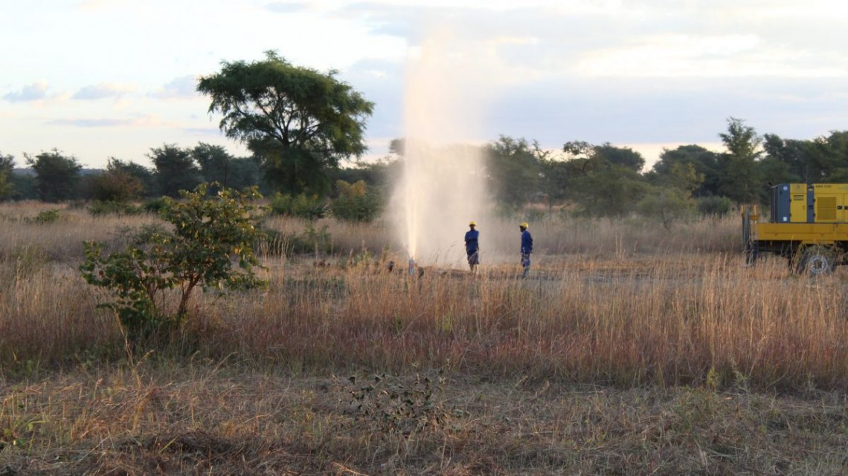  © World Bank

