DIGITAL CONTENT GUIDELINES
EU INTERNATIONAL PARTNERSHIPS

CONTENT TYPE: PROJECTS
Projects aim to showcase what the EU and its partners do in a certain region and country, giving concrete examples and underlining these examples with facts and figures.

All projects therefore include a sidebar giving key information on:
- the project duration
- the location
- the total budget
- the EU’s contribution

We also include information on the implementing partners of a project.

In terms of presentation of the projects, it should be factual, yet engaging.

- Choose a short but clear title, including the main keywords (What is it about? What does it do? Where does it take place?)
- Select a picture that fits the message of the page. It will be used as the ‘preview picture’ and will appear at the top of the project page
- Start the text section with an abstract summarising the project
- Continue with the objectives, project activities and results (or expected results)
- Use headings and paragraphs to structure the text
- For the paragraphs: one paragraph should represent one idea
- Use bullet points where possible to list different ideas – they can be easier to read online than passages of text
- It may be possible to insert a second picture or embed a video about the project, but the text message is still the most important element of the project!
See our digital content guidelines for more guidance on tone of voice, photos and videos.

How to use this template
This template is designed to help you provide the type of content we publish on the EU International Partnerships website. It is pre-filled with an example: Empowering young citizens in Sudan through democratic education
Simply replace the text and photos in the pre-filled sections and send the template back to INTPA-WEB@ec.europa.eu
Fields marked with a * are obligatory.
Please note that the text may be edited to comply with European Commission guidelines for content on ‘Europa’.
Please provide the name and email address of someone we can contact if we have further questions on this project:
Contact person name and email address

Title *  Use short, engaging titles. Avoid using abbreviations (unless they are well known to the general public) | Empowering young citizens in Sudan through democratic education
Story preview picture *  This picture is used on the index page for projects. It will appear at the top of the project page too.  Don’t forget to indicate the copyright holder and ensure you have the permission of any subjects in the photo. | 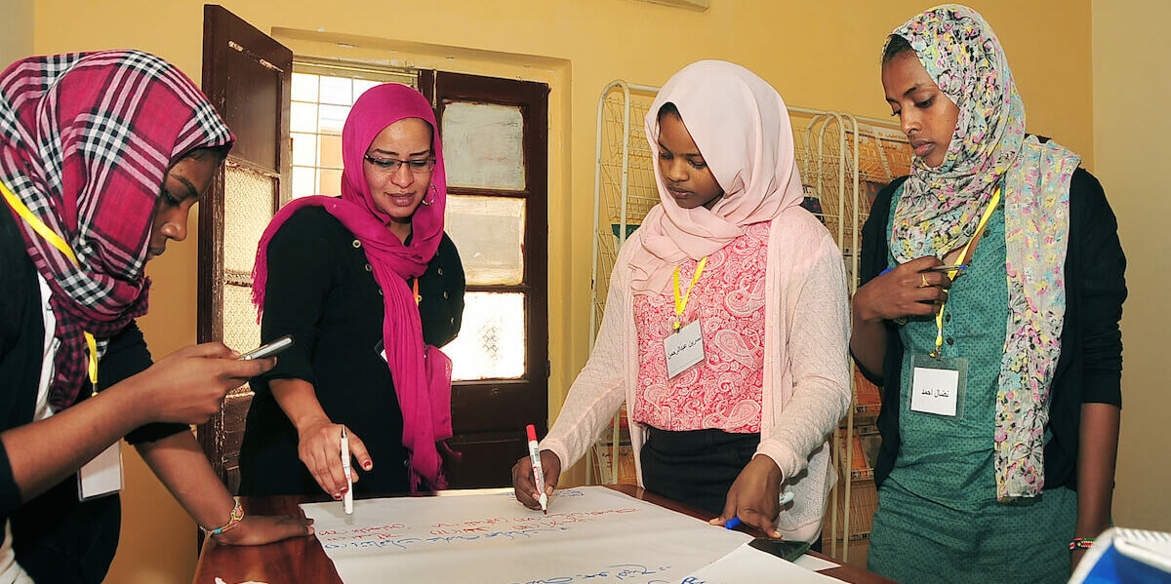  © Friedrich-Ebert-Stiftung Sudan
Image caption | Supporting democratic competition ahead of elections in Sudan
Introduction  Include a short abstract to explain what the project is about, why it is important, what change it brings/has brought. | The main objective of the EU-financed project ‘Strengthening Young Citizens in Sudan through Democratic Education’ is to increase youth participation in the democratic process and to contribute to the establishment of a credible and legitimate democracy in Sudan.  It aims to help students understand democratic processes and the importance of their participation in the election process, may elections be finally organised in Sudan.
Objectives *  Describe the current situation, the problem the project aims to tackle. Include facts and figures if available. | The project aims to allow young first-time voters to participate in future elections in a well informed and critical manner, and to formulate and voice their demands clearly in front of parties and governmental institutions, challenging the latter to actively take into account what future generations want and need from them. The overarching idea is to strengthen the principle of democratic competition ahead of the elections. The project is implemented by the German foundation, Friedrich-Ebert-Stiftung (FES).  More specifically, the project seeks to:  - strengthen the capacity of first-time voters (in view of possible future elections) and increase their knowledge about the issues at stake in the electoral process and civil rights  - raise awareness on the interests of young people in Sudan among political decision-makers

Project activities | - Workshops on civic and political education  - Conducting studies to gather information on the scope and thrust of political interests among young Sudanese and offering recommendations on youth policy needs  - Multiplying activities through peer-to-peer gatherings in order to further share concepts and knowledge around civic/political education
(Expected) results | Workshops and other activities have resulted in a 60% representation of women involved as lecturers, coordinators as well as participants. Furthermore, the project core team itself is 60% female.  An added value of this action is that it ensures the inclusion of many segments of the young population, i.e. young people from different economic and social backgrounds, students, but also the grassroots level.  The project has been selected among the 60 projects presented at the 2022 Paris Peace Forum.
Optional 2nd image or link to video  With caption and copyright info as necessary. | 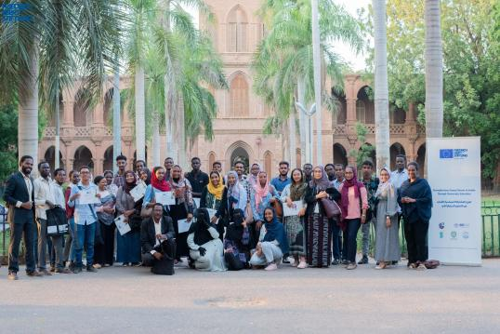  Strengthening young citizens in Sudan through democratic education  © Friedrich-Ebert-Stiftung Sudan
Key info | - project duration (format 01.03.2021 - 31.08.2023)  - location  - total budget  - EU’s contribution  - Implementing partners
Related links | E.g. project or partner websites

